Chemistry 4055 (Spring 2013)
Biochemistry I- Introduction to the Chemistry of the Animal Cell
Chapter 4-Lecture 2 HW Assignment

Please be concise and type your answers in this word document or write your answers on a separate sheet of paper.

1. Is the folded state of a protein always the most thermodynamically stable form of the protein? Explain.

2. In an individual fibrous protein, how many different types of secondary structure do you find?

3. The coiled coil structure of certain fibrous proteins is what level of protein structure?

4. For globular proteins, what is one of the major noncovalent interactions that results in the compact fold of these proteins?

5. Imagine that the cartoon below is a tetrameric protein and you are looking at it from a top-view. What is the geometry of this protein? By what angle must you rotate the protein to superimpose the subunits?

6. Many different spectroscopic techniques can be used to measure protein thermal stability. In the figure below CD spectroscopy at 209 nm was used to first study the thermal denaturation (○) from 5 to 75 °C of a protein and then to study the thermal renaturation (♦) from 75 to 5 °C of the protein. What does the data indicate about the reversibility of the process?

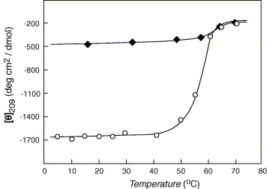

7. What does the shape of the thermal denaturation curve in problem #6 suggest about the denaturation process?

8. How does peptide prolyl cis-trans isomerase (PPI) contribute to protein structure?

9. Membrane proteins, which are notoriously insoluble proteins, are difficult to characterize by x-ray crystallography and NMR. How can you try to get some insight into the structure of these proteins?

