Chemistry 4055 (Spring 2013)
Biochemistry I- Introduction to the Chemistry of the Animal Cell
Chapter 6 HW Assignment

1. In the absence of a prosthetic group would an enzyme be able to catalyze a reaction?

2. If an enzyme can catalyze the conversion of a substrate to a product how then can it catalyze the conversion of the product to a substrate? Draw a reaction coordinate diagram to show this.

3. What ΔG value for the conversion of a substrate to a product is affected by the presence of an enzyme?

4. What thermodynamic equation shows that a higher K value results in a thermodynamically more favorable reaction?

5. Why is the lock and key theory an inappropriate model for the mechanism of enzyme catalysis?

6. In an important step in the mechanism of action of carbonic anhydrase, a Zn²⁺ ion helps to deprotonate a water molecule that coordinates to it. The hydroxide ion then serves as a nucleophile to attack the substrate CO₂. What kind of covalent catalysis mechanism is illustrated here? 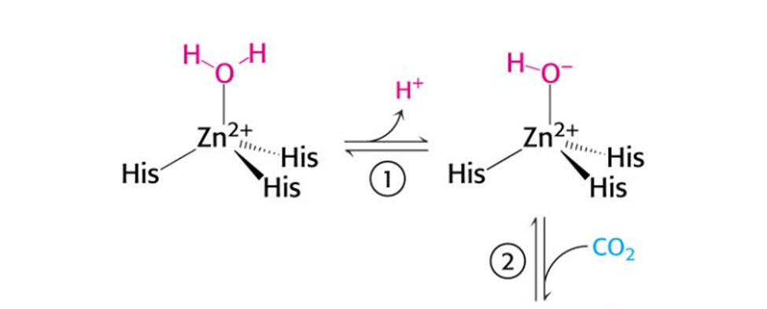
7. When performing a kinetics experiment it is important to be able to detect a substrate and/or a product to calculate rates. Often UV-vis spectroscopy is used because substrates and/or products can absorb light. If the substrate and product absorb light in a similar wavelength range, then why would an isosbestic point be important to identify in the UV-vis spectrum?

8. If enzyme kinetics were not measured by the method of initial rates, would the k₋₂ term still be negligible in the following proposed mechanism?

k₁ k₂
$E + S ES E + P$
k-₁ k₋₂
9. How is the steady-state assumption in enzyme kinetics similar to but not the same as chemical equilibrium?

10. Given the Michaelis-Menten parameters for an enzyme-catalyzed reaction k_{cat} = 30.0 s⁻¹ and K_{m} = 0.0050 M, determine the fraction of V_{max} that would be obtained at [S] = 10 K_{m}.

11. Estimate the V_{max} and K_{m} of the enzyme-catalyzed reaction for which the following data were obtained.

[S] (M) | V₀ (µM/min)
2.5 x 10⁻⁶ | 28
4.0 x 10⁻⁶ | 40
1 x 10⁻⁵ | 70
2 x 10⁻⁵ | 95
4 x 10⁻⁵ | 112
1 x 10⁻⁴ | 128
2 x 10⁻³ | 139
1 x 10⁻² | 140

12. How do competitive, uncompetitive, and mixed inhibitors effect the V_{max} and K_{m} of an enzyme-catalyzed reaction?

13. List five factors that affect enzyme activity whether positively or negatively.

14. How might a plot of enzyme rate (or velocity) versus pH give insight into important residues at the active site?

